SWOT Analysis Supporting Facebook

iRobot
Prepared by: Seth Ricks
Date: 8/22/2025

SWOT Diagram
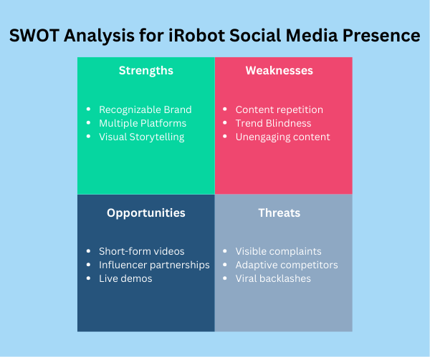

SWOT Outline
Thesis Statement:
iRobot has a presence on several social media platforms, but the one that needs the most improvement is Facebook. Many Millennials and Gen-Z’s use Facebook and are the ones that are disapproving of iRobot on their page. A SWOT Outline of iRobot’s Facebook presence is given below.
- Strengths
  - Recognizable Brand: iRobot is easily recognized as the creator of Roomba.
  - Multiple Platforms: iRobot is present on Twitter, Instagram, and Facebook.
  - Visual Storytelling: iRobot’s Facebook page tells visual stories of people enjoying their product.
- Weaknesses
  - Content repetition: iRobot’s content on Facebook is repetitive and may lose user interest over time.
  - Trend Blindness: The page doesn’t take advantage of current viral trends or ‘meme’ templates, which their target audience is accustomed to.
  - Unengaging content: The Facebook page content is long, boring, and unengaging. It is easy to lose interest quickly.
- Opportunities
  - Short-form videos: People of all ages are now accustomed to short-form content, such as short reels and videos.
  - Influencer partnerships: Many people will listen to a celebrity they like or follow.
  - Live demos: Demonstrating the product live, possibly with an influencer, could boost user numbers.
- Threats
  - Visible complaints: Almost all the posts on Facebook page have comments with complaints about iRobot’s products and customer service.
  - Adaptive competitors: Comparing iRobot’s Facebook page with Shark’s (one of their competitors) it is obvious that Shark cares more about making interesting content.
  - Viral backlashes: Simply looking up ‘Viral Backlash Roomba Facebook’ on a web browser shows all the problems that iRobot has been dealing with, such as security and privacy issues.
Conclusion:
iRobot can improve its social media platforms, Facebook in particular. While their page has some strengths, they are not reacting appropriately to what social media users are accustomed to. They are also not keeping up with their competitors’ content. It is almost like social media is working against them.
Note for presentation: (L13 Social Media Portfolio: Presentation)

Review your previous social media assignments. Use words, headings, and body paragraphs from your previous social media assignments to plan your presentation.
- Cover page slide.
  - Detailed, engaging title.
  - Name of presenter.
  - Contact points for presenter (email, phone number, and so on).
- Outline slide.
  - Bulleted outline.
  - No more than three descriptive words per point.
- Body and context slides.
  - Slides should not distract from the verbal presentation.
  - Each slide should relate to a specific bullet point recorded somewhere on the slide.
  - One topic with only one or two main takeaways on every slide.
  - Slides should not contain the full text of what the presenter is saying.
  - Graphics should supplement the text, not entertain.
- Write the full script of what the presenter will say in the notes section on each slide of the PowerPoint presentation. Writing out the script is a useful practice for when you may need to create a PowerPoint for someone else, like a company executive, to present. It will also help your instructor understand the full message of the presentation since you won't be presenting it in person.

You have developed a plan to improve your company’s image through social media. Now you need to present your plan to the board of directors in a meeting

The notes section presents full spoken script. Graphics support and enrich the written text and are not simply decoration. Text and graphics are simple and not text-heavy.

One point at a time is presented. Animation is used if multiple bullets are on one slide.

A slide with the outline, at the beginning of the PowerPoint, is provided. A section of the outline appears on the following slides to guide the audience.

Text strongly contrasts against the PowerPoint background.

Specific Considerations: 10 slides or fewer.

